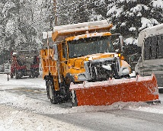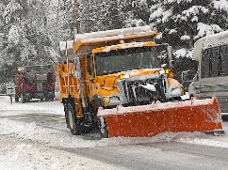 **SNOW REMOVAL POLICY**

**WASHINGTON PARK**

Updated 12/1/2018

It is imperative that EVERYONE comply with this policy so that our parking lot can be effectively plowed and safely maintained. If you are unable to move your vehicle or if you are planning on being away anytime during the winter months consider entrusting your keys to someone who can move your vehicle. Vehicles can also be moved to the tow-free-long-term parking area across from Lexington House #30. If there are any additional directions or alterations to this policy they will be communicated to the residents by the Management Company in a timely fashion. No one should interfere with the contractors during the time of snow removal. If you have any issues please contact the Management Company at 617-536-4900.

**During snow storms:**

* The snow contractor will begin plowing the roadways after 2 inches of snowfall.
* In order for the snow removal process to go as smoothly as possible, **vehicles must remain in their parking spaces during the storm event**.
* The main roadways, walkways, and stairs in front of each building will be cleared and ice melted during the storm as needed between 4:00 a.m. and 9:00 p.m.

**After the snow has stopped:**

* If the snow is stopped by 9:00 a.m., all cars must be moved from the parking spots so the snow plow contractor can finish the clean-up process. Please clean off your car in your spot, not in the newly plowed roadway.
* Vehicles should be parked along the roadways next to the river on both sides of the property to allow the contractor plenty of room to clean parking spots.
* If the storm continues for more than one day, the 9:00 a.m. deadline applies to each morning after.
* If the storm finishes late morning or afternoon, we still ask that people move their cars the next morning so that the plow can come through for a final clean up.
* All courtyard walkways, dumpsters, fire hydrants and mailboxes will be cleared when snow has stopped. A path to the doors on the decks and patios will be cleared (NOT the entire deck or patio).

** TOWING **

**VEHICLES NOT MOVED AS REQUIRED ABOVE WILL BE TOWED AT THE OWNER’S EXPENSE.** Elm Street Towing is our tow service, they can be reached at 978-475-5873. If you choose **NOT** to call the tow company and make arrangements to retrieve your vehicle they will add storage fees of $35.00 per day on to the original towing fee.